Stochastic Trees and the StoTree Modeling Environment: Models and Software for Medical Decision Analysis
Gordon B. Hazen
Northwestern University
June 2001

Abstract
In this paper we present a review of stochastic trees, a convenient modeling approach for medical treatment decision analyses. Stochastic tree are a generalization of decision trees that incorporate useful features from continuous-time Markov chains. We also discuss StoTree, a freely available software tool for the formulation and solution of stochastic trees, implemented in the Excel spreadsheet environment.

What is a Stochastic Tree?
Stochastic trees, introduced by Hazen (1992, 1993) are a type of Markov chain model designed specifically for medical decision modeling. Markov chain models were introduced to the medical literature by Beck and Pauker (1983), and provide a convenient means to account for medical treatment options and risks that occur not only in the present but also in the near and distant future. For a more recent introduction to Markov models in medicine, see Beck and Sonnenberg (1993).
A stochastic tree can be characterized in several equivalent ways:
- As a continuous-time Markov chain with chance and decision nodes added
- As a decision tree with stochastic transitions added
- As a multi-state DEALE model (Beck, Kassirer and Pauker 1982)
- As a continuous-time version of a Markov cycle tree (Hollenberg 1984)
We discuss both the graphical and the computational features of stochastic trees.

Graphical features of stochastic trees
The stochastic tree in Figure 1 is a model of risk of recurrent stroke following carotid endarterectomy, based on Matchar and Pauker (1986). Nodes such as “Well”, “Stroke”, and so on, depict health states. A health state can have incremental impact or instantaneous impact, depending on the type of arrows emanating from it. Wavy arrows emanate from incremental impact states such as “Well” or “Post Big Stroke”, and indicate that the incremental impact state is occupied for a duration that is uncertain but dependent on the rates that label the arrows. For example, the state “Well” is occupied until either a stroke occurs (the average stroke rate is m_{s} = 0.05/yr.) or death occurs due to other causes (the rate is m₀ + m_{e} = 0.0111/yr. + 0.065/yr = 0.0761/yr), at which time transition occurs to either “Stroke” or “Dead”, respectively. Incremental impact states act just like nodes in a transition diagram for a continuous-time Markov chain. Sometimes we will call such nodes stochastic nodes, and will refer to the associated arcs as stochastic arcs.
Straight arrows emanate from instantaneous impact states, and indicate that transition occurs immediately to a subsequent state with probability equal to the probability labeling the corresponding arrow. For example, in Figure 2, “Stroke” is an instantaneous impact state that leads with probability p_{b} = 2/3 to the state “Big Stroke” and probability 1−p_{b} = 1/3 to the state “Small Stoke”. Instantaneous impact states act just like chance nodes in a decision tree. We will therefore call such nodes chance nodes, and will refer to the associated arcs as chance arcs.
Transition cycles are also allowed in stochastic trees. In Figure 3, transition cycles are depicted using phantom nodes, nodes with dashed borders that are copies of other nodes in the stochastic tree. For example, the second “Big Stroke” node in the model has a dashed border, indicating that it is identical to the previous “Big Stroke” node. The net effect is that with rate p_{b}⋅m_{s}, transition can occur from state “Post Big Stroke” back to previously visited state “Big Stroke”. There is also a phantom node “Stroke”, which allows transition from state “Post Small Stroke” to the previously visited state “Stroke”.
The stochastic tree diagram in Figure 1 was produced inside an Excel workbook using the Visual Basic software StoTree developed by Hazen. We discuss this software in more detail below.
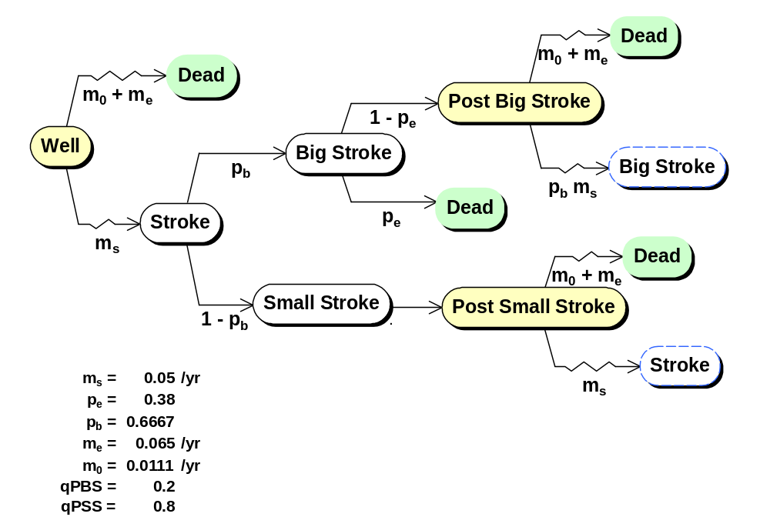
Figure 4: A stochastic tree model of recurrent stroke following carotid endarterectomy, based on Matchar and Pauker (1986). This model was formulated in an Excel spreadsheet using the StoTree software.

Computational features of stochastic trees
Mean quality-adjusted lifetime can be computed easily in stochastic trees using rollback procedures not unlike those for decision trees. As noted by Hazen (1992), these rollback procedures arise from the equivalence
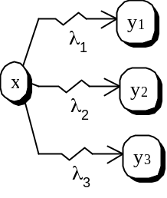 | = | 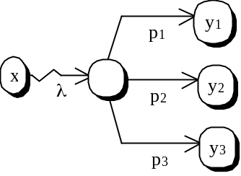
λ = 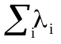 p_{i} = λ_{i}/λ
known as superposition/ decomposition in the stochastic processes literature. This diagram indicates that multiple competing transitions out of a state x to states y₁, y₂, y₃ at competing rates λ_{1,} λ₂, λ₃, are equivalent to a single transition out of x at rate λ = λ₁ + λ₂ + λ₃, followed by an immediate transition to y₁, y₂, or y₃ with probabilities p₁, p₂, p₃, where p_{i} = λ_{i}/λ. This equivalence leads to the following rollback procedure: If L(x) is mean quality adjusted duration beginning at state x, then
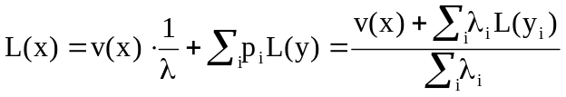
Here L(y_{i}) is mean quality-adjusted lifetime beginning in state y_{i}, and v(x) is the quality adjustment for time spent in state x.
The StoTree software implements this rollback procedure and places the resulting formulas for mean quality-adjusted durations directly into the Excel spreadsheet. The rollback results for the Matchar and Pauker example from Figure 5 are displayed in Figure 6.
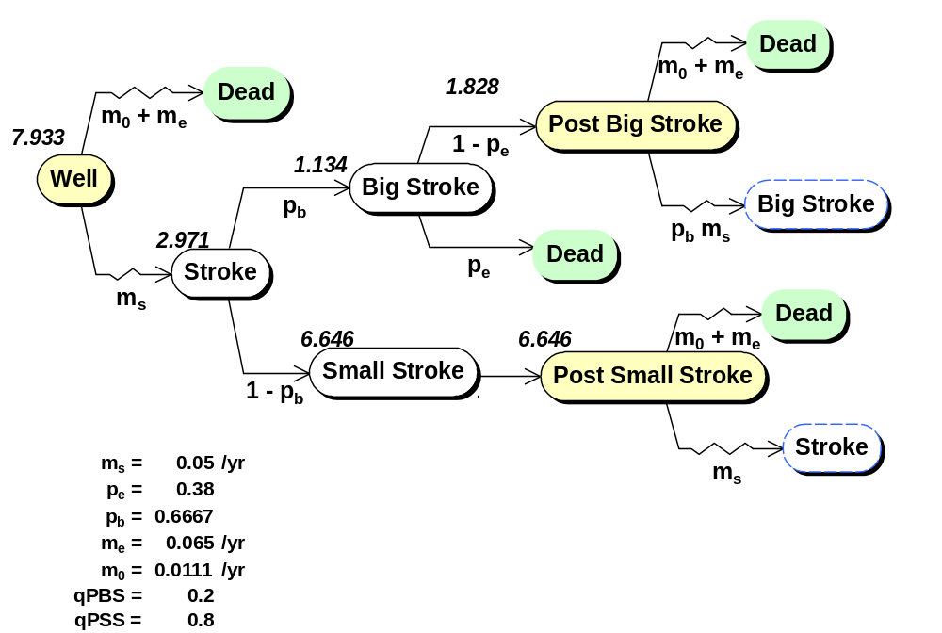
Figure 7: Rollback results for the Matchar and Pauker model from Figure 8. The quality adjustments for the Well, Post Big Stroke, and Post Small Stroke states are 1, qPBS = 0.2, and qPSS = 0.8. Mean quality adjusted lifetime beginning in the Well state is 7.933 years. Other states are labeled with mean quality adjusted lifetimes beginning at those states.

Factored Stochastic Trees
We consider a Markov model discussed by Beck and Sonnenberg (1993), whose essential characteristics are as follows:
- A 42-year old man received a kidney transplant 18 months ago. Normal kidney function has been maintained under immunosuppressive therapy.
- Recently, two synchronous melanomas appeared and required wide resection
- Should immunosuppressive therapy be continued?
–Continuation increases chance of another possibly lethal melanoma
–Cessation ensures kidney rejection and dialysis
A stochastic tree depicting this decision problem is given in Figure 9. The decision to stop immunosuppressive therapy results in immediate kidney rejection and the initiation of dialysis. Stopping immunosuppressive therapy lowers the melanoma recurrence rate, but initiating dialysis increases the mortality rate. Notice that there are two phantom nodes, Dialysis and Dialysis/Melanoma which lead back to other portions of the tree.
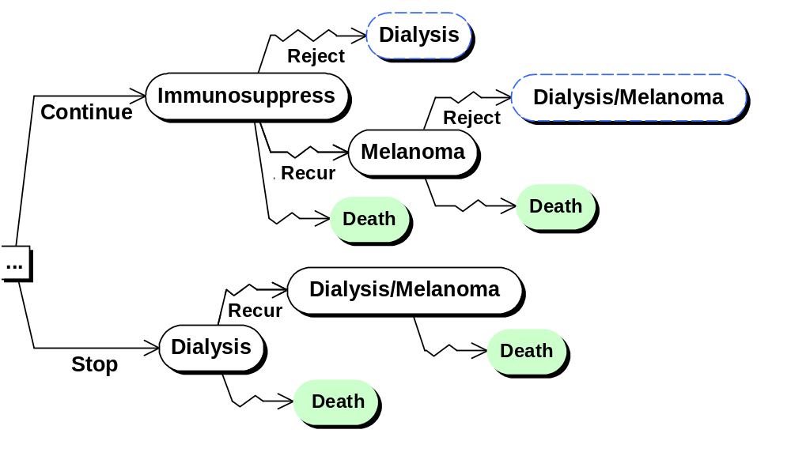
Figure 10: A stochastic tree model of the decision to continue immunosuppressive therapy in a patient subject to increased cancer risk, following Beck and Sonnenberg (1993).

One cumbersome feature of the model in Figure 11 is the apparent necessity to include a possible transition to death out of each state. Because everyone understands there is some mortality risk regardless of health state or treatment choice, perhaps it would be simpler to acknowledge this once, and separate this feature from the main decision model. One way to accomplish this graphically is shown in Figure 12. Here the mortality process has been separated out, and an arrow from the main model to the mortality process has been added to indicate that mortality rate can be affected by the state of the main model. The mortality process and the processes in the main model proceed in parallel. We say we have factored out mortality from the main model, and we call the result a factored stochastic tree. An advantage of factoring out mortality is that the structure of the main model can be more easily discerned once all the death transitions have been removed.
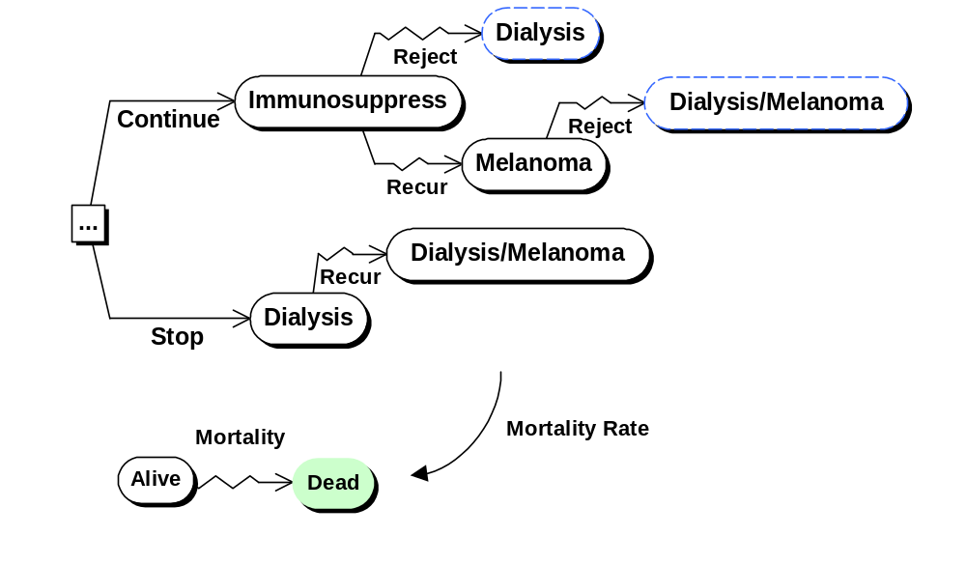
Figure 13: Factoring mortality out of the Beck and Sonnenberg model of Figure 14. Mortality rate depends on the state of the main model.

However, once we are aware of the possibility of factoring, there is no reason to limit ourselves to factoring out mortality. In addition to mortality, the main model has three other processes that proceed in parallel:
- the cancer recurrence process
- the kidney rejection process
- the initial process of deciding whether to stop immunosuppressive therapy.
If we factor out these processes as well, we obtain the factored stochastic tree of Figure 15. The figure depicts the component processes and also how they influence each other. In addition to the influences on mortality rate, we see that the decision to continue or stop immunosuppressive therapy influences cancer recurrence rate. There is also a triggering influence: the decision to stop immunosuppressive therapy triggers an immediate transition from Well to Dialysis in the Transplanted Kidney factor.
It is important to remember that in a factored stochastic tree, the factors depict processes that are proceeding in parallel. So any combination of states, one from each factor, may in principal occur. For example, the Dialysis/Melanoma state in Figure 16 may seem absent from the factored tree in Figure 17, but it is represented implicitly by the combination of states Dialysis in the Transplanted Kidney factor, and Melanoma in the Cancer factor.
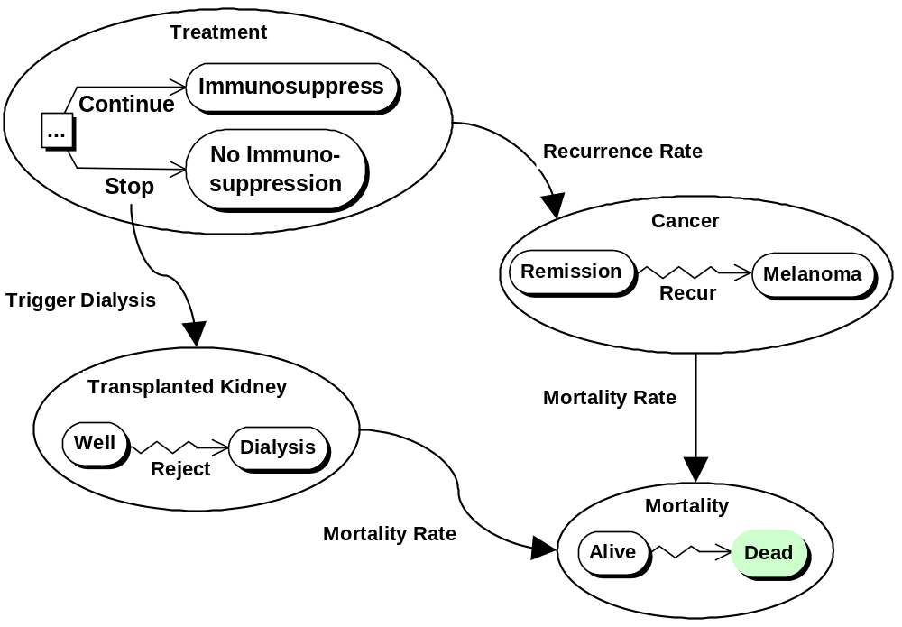
Figure 18: A complete factoring of the Beck and Sonnenberg model. Three competing processes (cancer recurrence, kidney rejection, mortality) follow the initial decision to continue or stop immunosuppressive therapy. Cancer recurrence rate depends on the state of the Treatment factor. Mortality rate depends on the state of the Transplanted Kidney factor and the state of the Cancer factor. A decision in the Treatment factor to stop immunosuppressive therapy triggers a transition to Dialysis in the Transplanted Kidney factor.

Factoring a stochastic tree in this manner has several advantages.
- It simplifies the model formulation process. The analyst can focus attention on one component (factor) of the model at a time, refining it as needed, and only later worry about other components and interactions between components.
- It allows the easy formulation of large Markov models. The Beck and Sonnenberg model of Figure 19 is only a small example. In our experience, models containing tens or hundreds of states may easily arise. These are readily handled in factored form because most factors contains on the order of 2 to 5 states. (See the DCIS example presented below.) Formulating large models such as these is impractical without factoring.
- It allows the easy swapping or adding of model components. The StoTree software allows the analyst to add, remove, or substitute model components (factors) as needed. This is described further below.
- It assists in the presentation of the model to others. Even those not versed in the theory of continuous-time Markov decision processes can gain a intuitive graphical understanding of simple 2- to 5-state factors of most models.

The StoTree Modeling Environment
StoTree is an Excel-based graphical modeling environment written in Visual Basic for constructing and solving factored stochastic trees. The user of StoTree can formulate his stochastic tree model on one or several worksheets within an Excel workbook. StoTree can take rates, probabilities, quality adjustments and discount rates as input from named cells in the Excel worksheet. Following rollback, StoTree places mean quality-adjusted durations directly into worksheet cells adjacent to the appropriate health states. These outputs link back to the input cells in order to facilitate sensitivity analysis.
We shall illustrate these and other features of StoTree as we have applied it to the formulation and solution of a model of treatment choice for ductal carcinoma in situ (DCIS), a precancerous condition whose treatment is controversial (Hazen, Morrow and Venta 1999). Traditionally, DCIS was a rare disease treated by mastectomy, but modern mammography has converted this unusual entity into a common pathological finding (Silverstein et al. 1992, Hiramatsu et al. 1995) Recently the need for surgery as extensive as mastectomy has been questioned, and alternatives have been proposed such as lumpectomy, or lumpectomy in conjunction with radiation treatment or the drug tamoxifen.

Graphical specification of model structure in StoTree
The StoTree user specifies the qualitative structure of the desired Markov model by graphically constructing a factored stochastic tree in an Excel workbook, with each factor occupying one worksheet in the workbook. The user creates a node representing a health state by selecting a worksheet cell near which the node should be placed and clicking on the “Create Node” icon on the StoTree toolbar. Figure 20 illustrates this process. The user may connect any two created nodes with a chance or stochastic arc by clicking the appropriate icon on the StoTree toolbar, as is described in Figure 21. StoTree also allows the user to create decision nodes, terminal (death) nodes, and phantom nodes. The user may also drag nodes to reposition them as desired, and then click on the Redraw icon on the StoTree toolbar to have StoTree redraw all connecting arcs to match the new node positions.
(a)  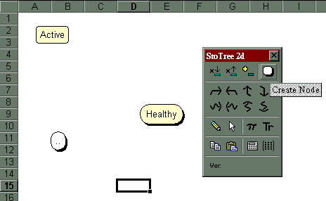 | (b)  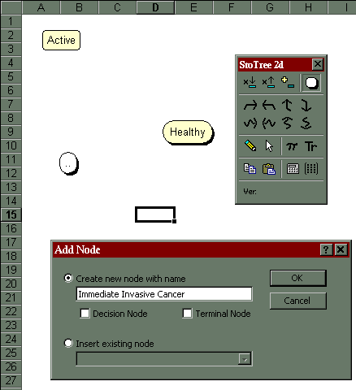
Figure 22: The StoTree user constructs a stochastic tree by first creating and naming nodes that represent health states. In (a), the user has highlighted cell D15 and clicked on the “Create Node” icon in the StoTree toolbar. As a result, in (b), StoTree’s Add Node dialog appears. The user then selects “Create new node with name”, types a name into the dialog box, and clicks OK. As a result, in (c), StoTree creates a node with that name near the highlighted cell.
(c)
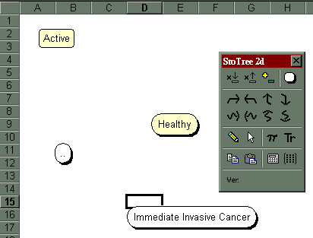

(a)  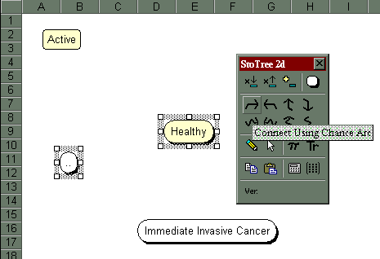 | (b)  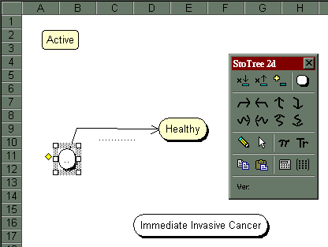
Figure 23: The StoTree user connects nodes s/he has constructed using either chance arcs or stochastic arcs. In (a), the user has selected the oval node and the Healthy node in that order and clicks on the “Connect Using Chance Arcs” icon on the StoTree toolbar. As a result, in (b), StoTree adds a directed chance arc from the first-selected node to the second. The user can select either chance or stochastic arcs in any of the four compass directions.

Parameter specification in StoTree
Once the user has specified the graphical structure of the stochastic tree model, s/he can proceed to associate quality adjustments with nodes, rates with stochastic arcs, and probabilities with chance arcs. S/he may also attach tolls (one-time penalties) to chance or stochastic arcs, and specify a rate for time discounting.
To illustrate this process, consider first the Ipsi Interventions factor for our DCIS model, shown in Figure 24. Here the possible interventions for the patient’s ipsilateral breast are portrayed following diagnosis of DCIS. The possible interventions are mastectomy, lumpectomy followed by radiation therapy (XRT), or lumpectomy only. The probability pSurgDeath (equal to 0.14%) of surgical death under mastectomy is contained in a spreadsheet cell adjacent to the Ipsi Interventions tree, as are the quality adjustments qPostMastectomy, qPostLumpXRT, qPostLump.
In StoTree, the user may set probabilities, rates and quality adjustments equal to specific numerical values, or to the contents of any named spreadsheet cell. (Naming cells is a standard Excel feature.) Figure 25 illustrates how the user may accomplish this. The advantage of referring to a spreadsheet cell instead of entering a numeric value is that the user may then conduct post-optimality sensitivity analysis. We discuss this below.

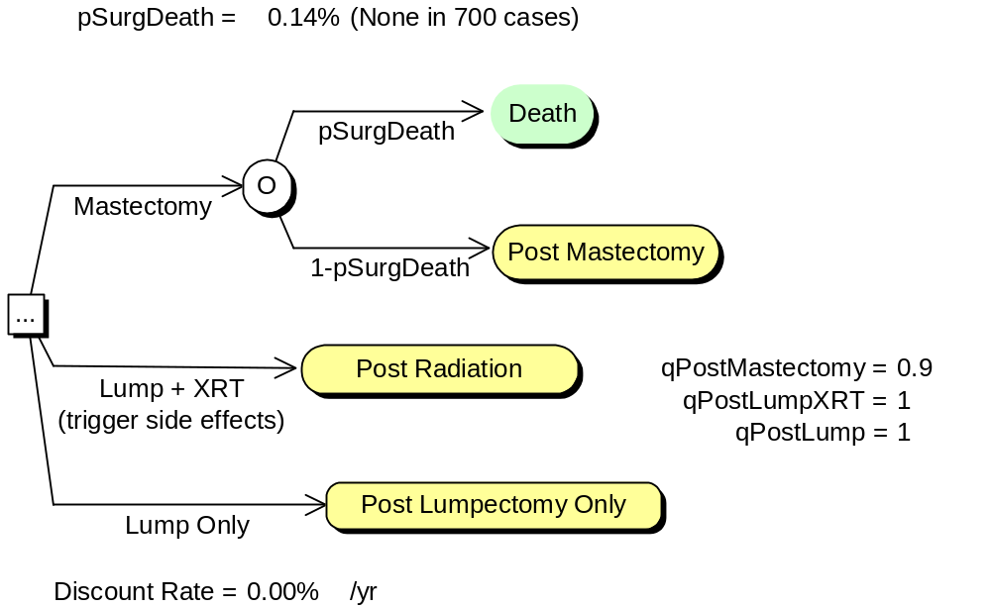
Figure 26: The Ipsi Interventions factor of our DCIS model.

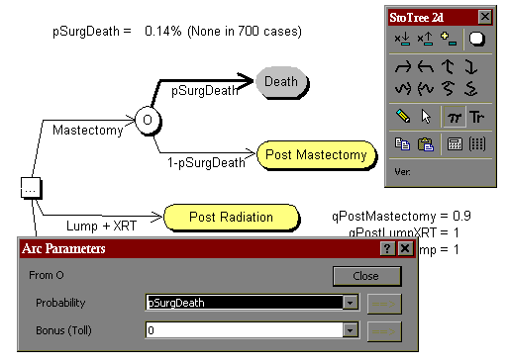
Figure 27: In StoTree, Probabilities and rates can be made to depend on named cells in the spreadsheet. Here the probability on the highlighted arc from node O to Death is set equal to the contents of the cell named pSurgDeath, which currently contains the value 0.14%. Similar dependencies can be set up for quality adjustments. For instance, the quality adjustment for the node Post Mastectomy has been set equal to the contents of the cell named qPostMastectomy, whose value is currently 0.9.

In the Ipsi Interventions factor, the choice of lumpectomy followed by radiation therapy (Lump + XRT) has an associated risk of side effects. These side effects are depicted in Figure 28, and include cosmetic effects such as breast shrinkage and toughening, as well as pneumonitis. To instruct StoTree that the choice Lump + XRT triggers the risk of side effects, the user selects the arc labeled Lump + XRT, clicks on the trigger icon on the StoTree toolbar, and enters the desired trigger, as described in Figure 29.

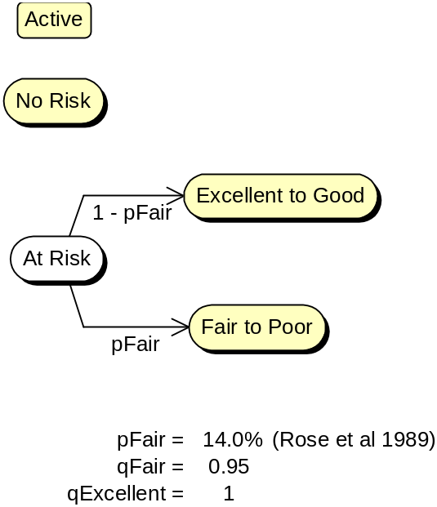 | 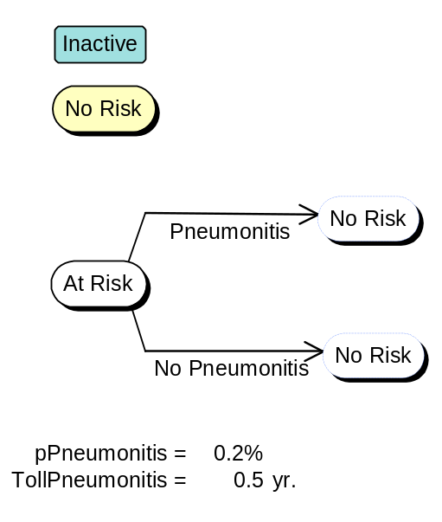
Figure 30: The factors Cosmetic Risk (left) and Pneumonitis (right). The user has made the Cosmetic Risk factor active, and the Pneumonitis factor inactive. Only active factors are part of the model. Initially, both factors occupy the No Risk state, but the choice of lumpectomy with radiation therapy in the Ipsi Interventions factor (Figure 31) triggers transition to the At Risk state.

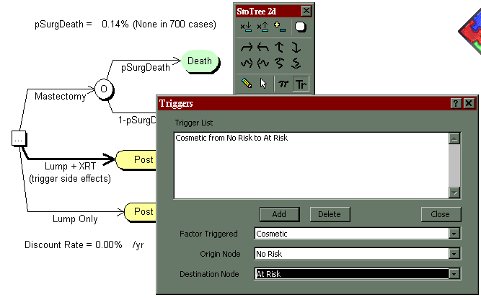
Figure 32: The StoTree user may attach a trigger to any arc by selecting the arc and clicking on the trigger icon on the StoTree toolbar. The Triggers dialog appears, in which the user specifies the factor to be triggered, the origin node and the destination node. Here the user has selected the decision arc for Lump + XRT and has attached to it a trigger of the Cosmetic factor from No Risk to At Risk (see Figure 33). Cosmetic risks due to radiation are therefore present in the model only for the choice Lump + XRT, and not for the choices Mastectomy or Lump Only.

Figure 34 depicts the other major factor in our DCIS model, the Ipsi Site factor. Here the long-term prognosis of patients following treatment is modeled. The rate of cancer recurrence in this factor depends on the treatment chosen in the Ipsi Interventions factor. Figure 35 illustrates how the user can enter this dependence.
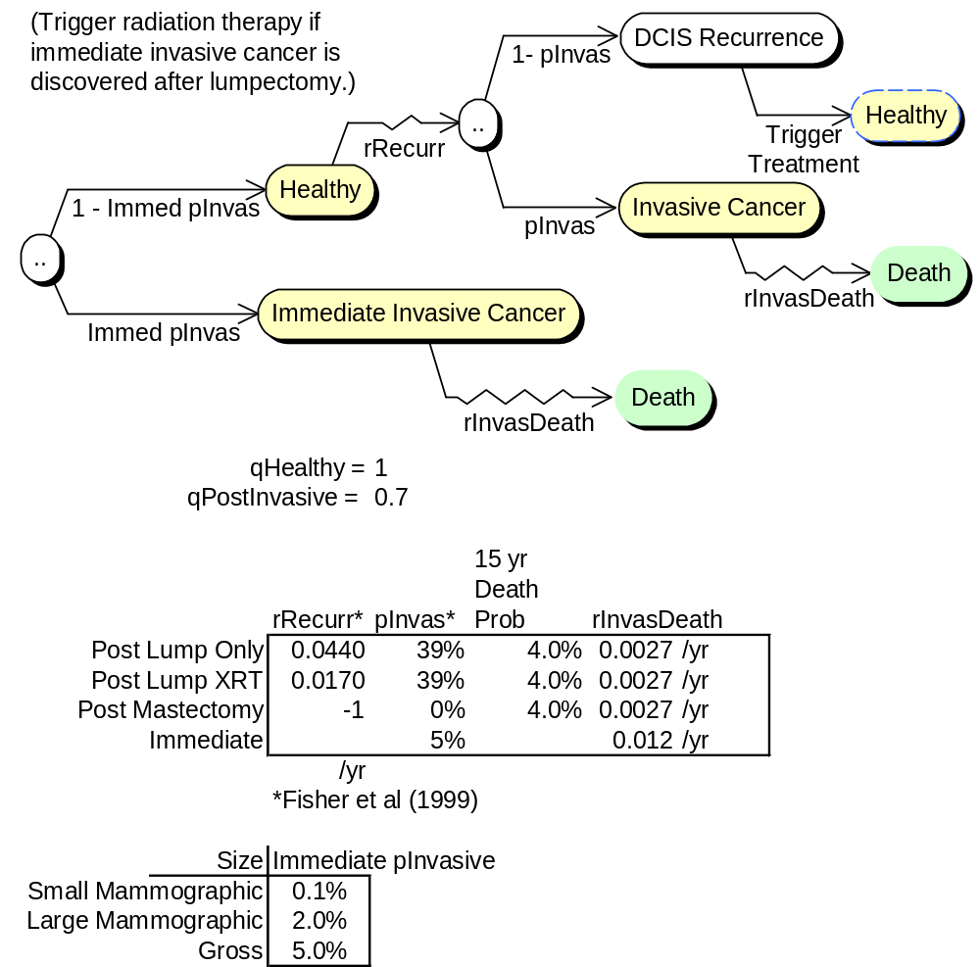
Figure 36: The Ipsi Site factor of our DCIS model describes long-term patient prognosis. There is some chance that the patient may have undetected invasive cancer. Barring this, a healthy patient is at risk of cancer recurrence, the rate of which depends on the treatment chosen in the Ipsi Interventions factor. If DCIS recurs, then a renewed choice of therapy is triggered in the Ipsi Interventions factor.

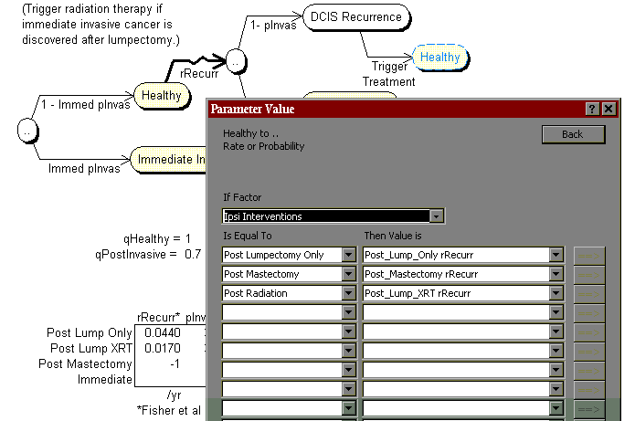
Figure 37: In StoTree, rates or probabilities in one factor may depend on the state of other factors. Here the user has instructed StoTree to set the rate rRecur of cancer recurrence on the highlighted arc to a value that depends on the state of the Ipsi Interventions factor. In particular, if the Ipsi Interventions factor is in the state Post Lumpectomy Only, then rRecur is set equal to the cell named Post_Lump_Only rRecur, which currently contains the value 0.0440. The value −1 in the cell named Post_Mastectomy rRecurr indicates that transition along the highlighted arc is not possible post mastectomy.

Model solution and sensitivity analysis in StoTree
When the user clicks on the rollback icon in the StoTree toolbar, StoTree will write rollback formulas directly into the current workbook, and will use these formulas to calculate mean quality-adjusted lifetimes beginning at each node in the tree. StoTree places the formulas for the resulting quality-adjusted life expectancies into cells adjacent to the associated nodes. The result of this process for our DCIS model is depicted in Figure 38. If the user specifies rates, probabilities and quality adjustments via named spreadsheet cells (Figures 39 and 40), then these rollback formulas will depend on the named spreadsheet cells: If the user changes any named cell and recalculates the spreadsheet, then the resulting quality-adjusted lifetimes will change accordingly. The user may therefore conduct sensitivity analyses on input parameters of interest. An example of this process for our DCIS model is given in Figure 41.
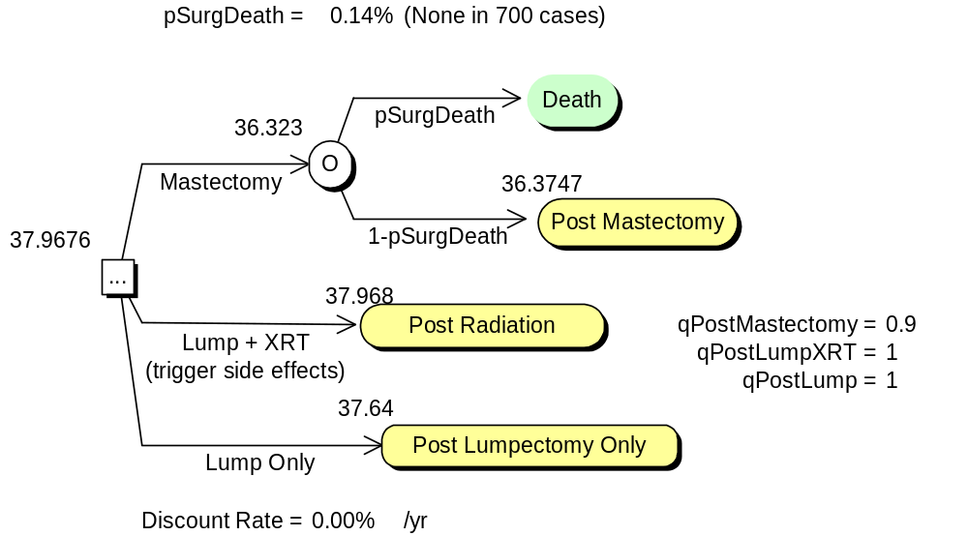
Figure 42: Following rollback, StoTree places quality-adjusted life expectancies in cells next to the appropriate nodes in each factor. For example, quality-adjusted life expectancy beginning at the node Post Radiation is 37.968 years for a 40-year-old white female. The optimal treatment is Lump + XRT (lumpectomy followed by radiation therapy).
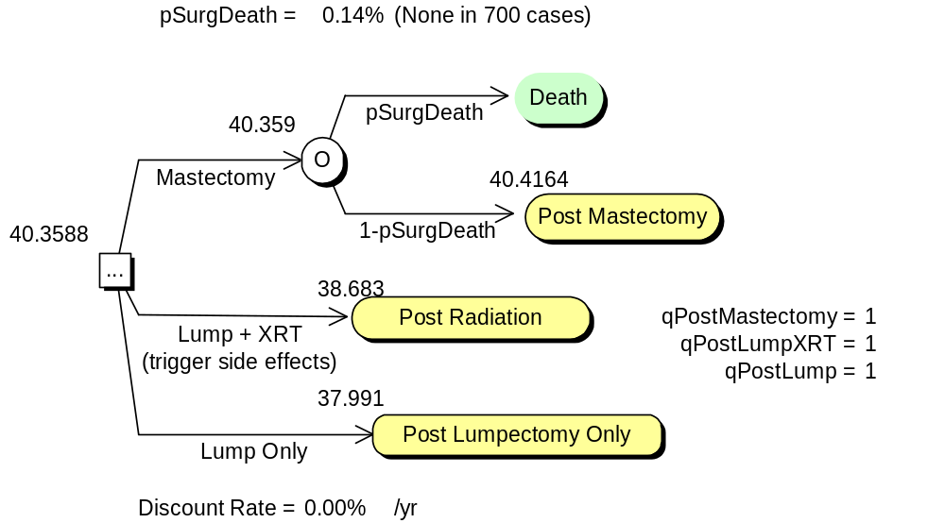
Figure 43: Because StoTree links the cells containing quality-adjusted life expectancies to cells in the spreadsheet containing probabilities, rates and quality adjustments, the user may conduct sensitivity analyses after rollback. Here the user has changed the quality adjustment qPostMastectomy for the state Post Mastectomy from 0.9 to 1 (compare Figure44) and recalculated the spreadsheet. Now the optimal choice is mastectomy. (The alternatives Lump Only and Lump + XRT also improve because with either of these therapies, mastectomy may occur upon recurrence.)

Software availability
The StoTree software and accompanying documentation is freely available at the author’s web site www.iems.northwestern.edu/~hazen.

Conclusion
Stochastic trees are a convenient and flexible modeling tool for the construction, solution and presentation of Markov models for medical treatment decision analysis. Stochastic trees have convenient graphical and computational properties not unlike decision trees. Moreover, large stochastic trees may be factored into manageable components, an option of considerable value in model formulation and model presentation. The freely available software StoTree implements these features using a graphical modeling interface within the familiar spreadsheet environment. This environment allows easy substitution and swapping of model components, and convenient sensitivity analysis capabilities.

References
JR Beck, JP Kassirer, SG Pauker (1982), “A Convenient Approximation of Life Expectancy (the “DEALE”): I. Validation of the method”, Am J Med 73, 883-888.
JR Beck and SG Pauker (1983), “The Markov Process in Medical Prognosis,” Medical Decision Making 3, 419−458.
G.B. Hazen (1992), "Stochastic Trees: A New Technique for Temporal Medical Decision Modeling," Medical Decision Making 12, 163-178.
G.B. Hazen (1993), "Factored Stochastic Trees: A Tool for Solving Complex Temporal Medical Decision Models," Medical Decision Making 13, 227-236.
GB Hazen, M Morrow, ER Venta, "Patient Values in the Treatment of Ductal Carcinoma in Situ", Society for Medical Decision Making Annual Meeting, Reno, Nevada, October 1999.
H. Hiramatsu, BA Bornstein, A Recht, SJ Schnitt, JK Baum, JL Connolly, RB Duda, AJ Guidi, CM Kaelin, B Silver, JR Harris, “Local Recurrence After Conservative Surgery and Radiation Therapy for Ductal Carcinoma in Situ”, Cancer J Sci Am 1995; 1:55-61.
JP Hollenberg (1984), “Markov Cycle Trees: A New Representation for Complex Markov Processes”, (abstr.), Medical Decision Making 4, 529.
DB Matchar and SG Pauker (1986), “Transient Ischemic Attacks in a Man with Coronary Artery Disease: Two Strategies Neck and Neck”, Medical Decision Making 6, 239-249.
MJ Silverstein, BF Cohen, ED Gierson, M Furmanski, P Gamagami, WJ Colburn, BS Lewinsky, JR Waisman, “Duct Carcinoma in situ: 227 Cases Without Microinvasion”, Eur J Cancer 28 (1992) 630-634.
FA Sonnenberg and JR Beck (1993), “Markov Models in Medical Decision Making: A Practical Guide”, Medical Decision Making 13, 322-338.

